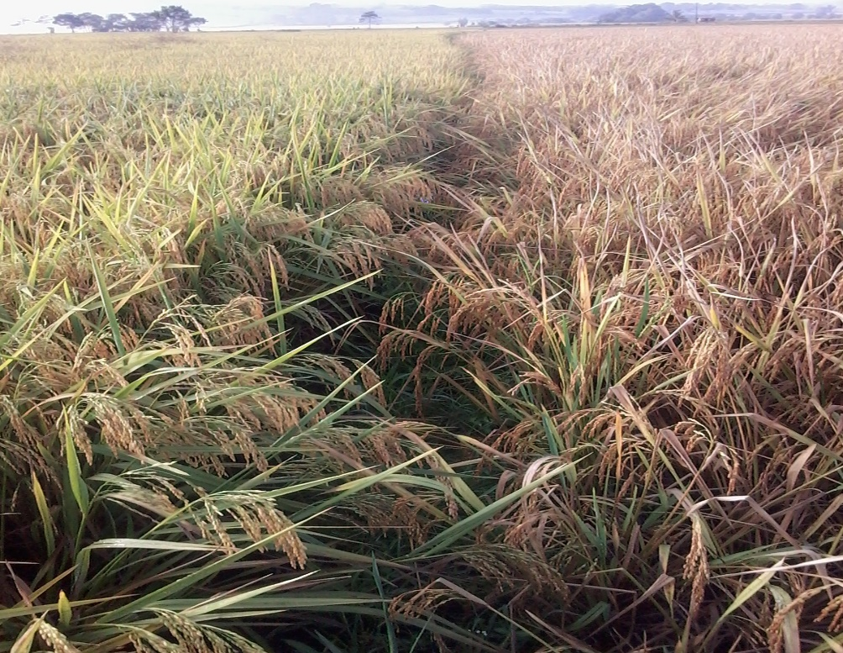

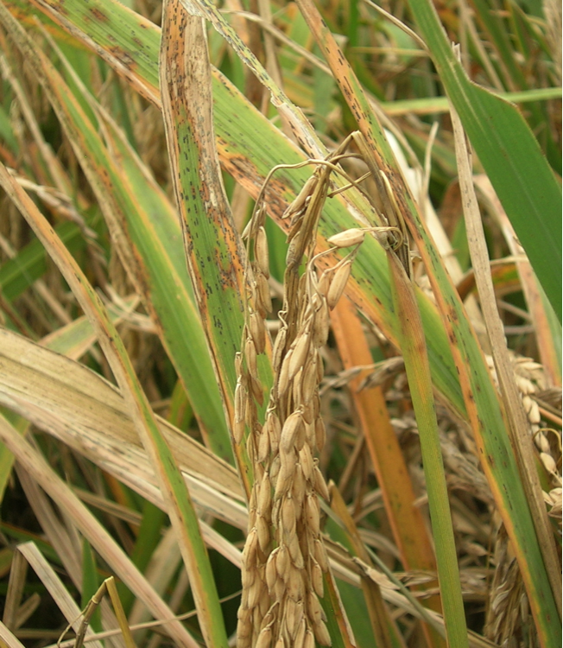
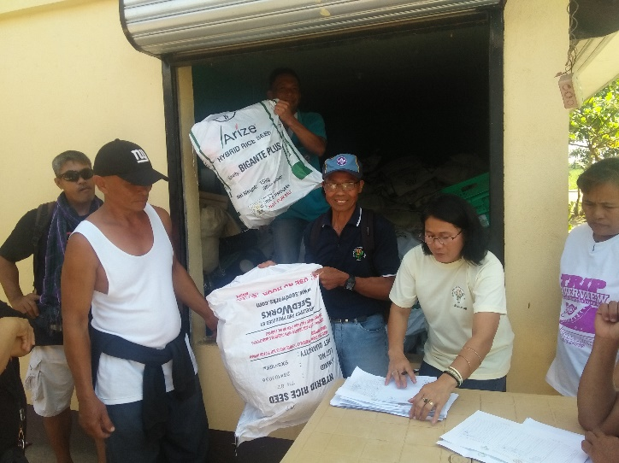
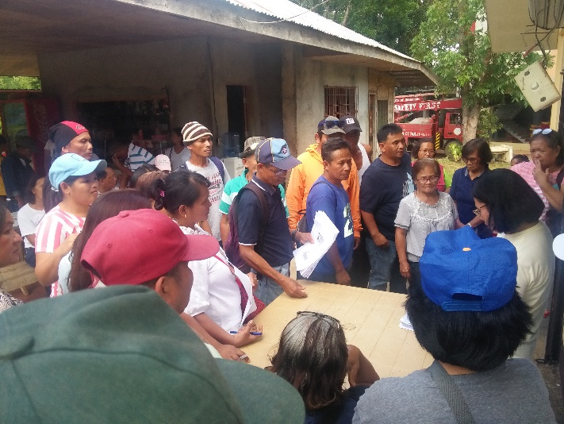
RICE INFECTED BY NECK BLAST
DA – LGU MASS DESPERSAL OF HYBRID SEEDS
OVER RIPE /
NO HARVESTER
READY TO HARVEST

